|  |
| --- |
| **STUDENT NAME** |
| Alley Chaggar |

**LAB #13**

BEFORE WE START 2

ACTIVITY 1 2

ACTIVITY 2 5

ACTIVITY 3 15

ACTIVITY 4 21

# BEFORE WE START

1. Double – click on the Blender icon on your desktop.
2. Close the tutorials windows.
3. Start rendering.

# ACTIVITY 1

## CHARACTER MODELLING SETUP

Blender 2.8 does not support the old good background images anymore. Though these images have gone obsolete we can add an image (or more than one) as background. We use two images of a little boy. One front and one side view. These images are imported as backgrounds and thus won’t be rendered.

Follow the steps below:

1. Download the KidFront.png and KidSide.png images from the Lab #13 Support Files in E-Centennial and save them to your computer.
2. Open Blender and click on the Cube.
3. Press Delete.
4. Under the Object Mode → Add → Image → Background.
5. Navigate to the file system and select the KidFront.png image.
6. Expand the Transform Properties and set the options as shown below:

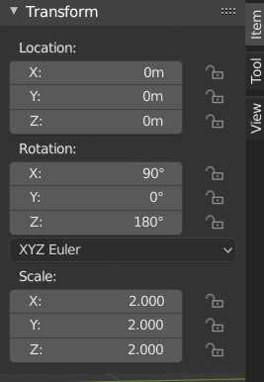

1. Repeat steps 4 – 6, but pick the KidSide.png image and set the properties as shown below:

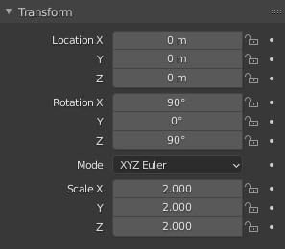

1. Adjust if needed and create a setup such as the one below:

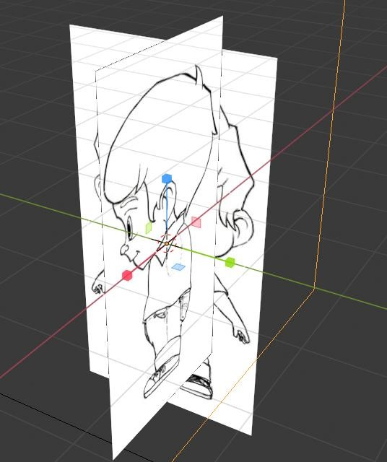

1. Split the Scene to two Views (Left – Front View and Right - Side View).
2. Select both images and move the Kid as to touch the Y axis with their feet, as shown below:

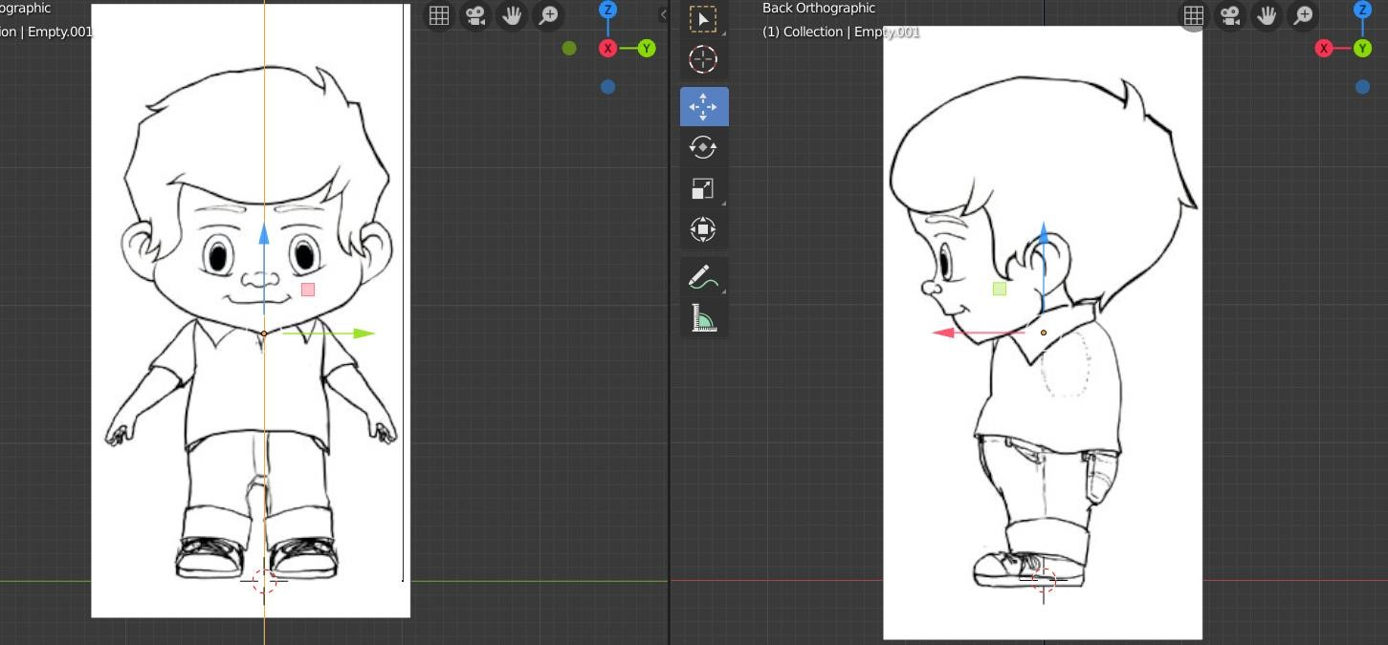

1. In the Scene Collection Menu rename the first (Front) image as FrontView and the second (side) as SideView.

|  |
| --- |
| **TASK 1.1:**  Take a screenshot of the setup and paste it below: |
|  |

# ACTIVITY 2

## DESIGNING THE BODY, THE FEET AND THE ARMS

The body, the feet and the arms are the main external figures of the human anatomy. We start with a simple cube close to the character’s belly area, we keep only a the right side and then we apply a Mirror modifier, simplifying the process. Then we Extrude and Bevel accordingly.

Follow the steps below:

1. Click on the X-Ray button.
2. Click Add → Mesh → Cube.
3. Position the cube as shown below.

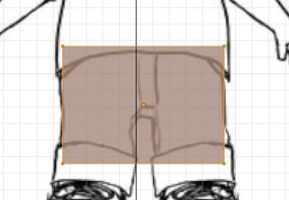

1. Switch to Edit Mode.
2. Click on the Loop Cut tool  (side left bar) and cut the object vertically, as shown below.

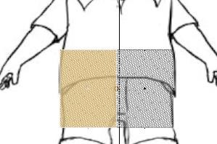 6. Press B and select the left side of the cube.

1. Press Delete and then Faces. Result:

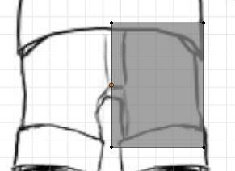

1. Click on the Modifiers Context tab.
2. Click Add Modifier → Mirror.
3. Select the Y Axis under the Axis options.
4. Select the Clipping option to avoid overlapping parts.
5. Select and move the cube upwards to match the size of the torso.
6. Scale the body to match the size again.
7. Select the vertices of the torso and move them to match the shape of the body.
8. Create Cuts as needed, as shown below:

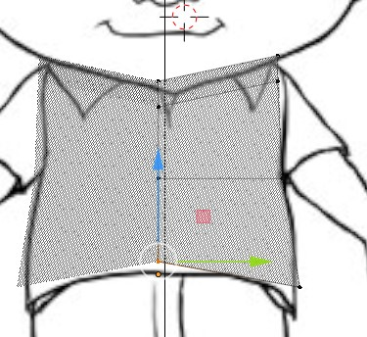

1. Switch to the Side View and repeat the same adding Cuts as needed.

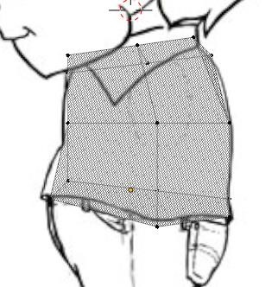

1. Click on the Face Selection.
2. Select the side of the torso, click on the Scale tool and reduce its size, as shown below:

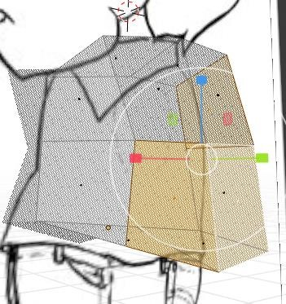

1. Move the individual vertices as needed.
2. Turn to the front and locate the lower body Faces (one or more), where the feet should be.
3. Select these Faces and click on the Extrude Region tool.
4. Extrude up to the feet length.
5. Then, select the lower Faces and move them (using the Transform panel) as shown below:

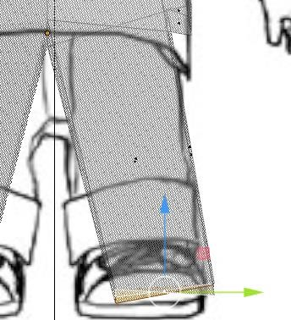

1. Switch to the side view and select the Vertex select mode.
2. Press B and select all the parallel vertices, moving them to match the background image.

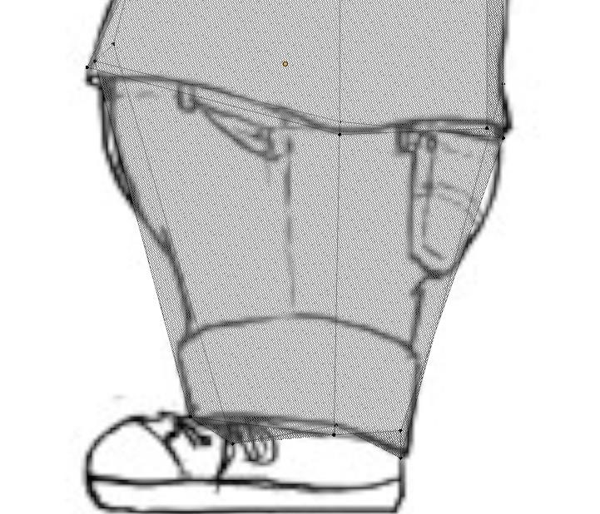

1. Select the Loop Cut tool and create a new Edge on the knee.
2. Select (with B) the vertices and move the to match the background.
3. Create any Loop Cuts needed, following the image below and move the vertices.

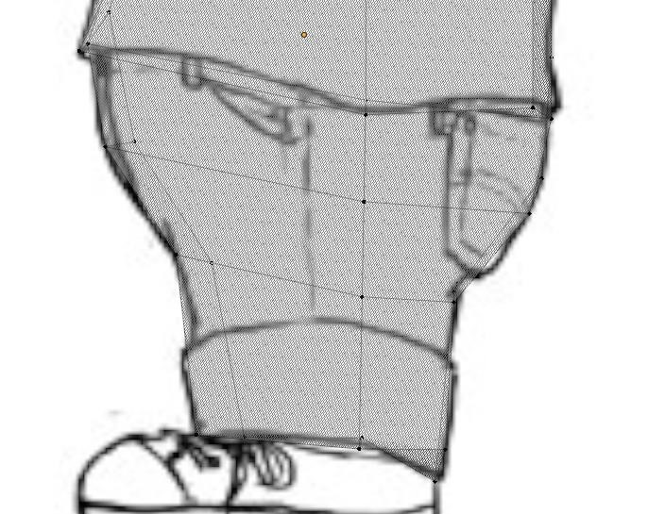

1. Switch to the Front View.
2. Select any Vertices look too pointy and create rounder areas.
3. Switch to Object mode.
4. Right – Click and click on the Shade smooth option.

Once you complete the previous steps:

|  |
| --- |
| **TASK 2.1:**  Take a screenshot of the character and paste it below: |
|  |

1. Switch to Edit Mode again.
2. Switch to the side view and select the Vertex or the Edge mode.
3. Move the edges or the vertices to match the shape of the base of the hand.
4. Then, select the area, clicking on the Edge and Face mode and pressing Shift+Ctrl and clicking two of the faces being on the opposite sides.
5. The result should be something like this:

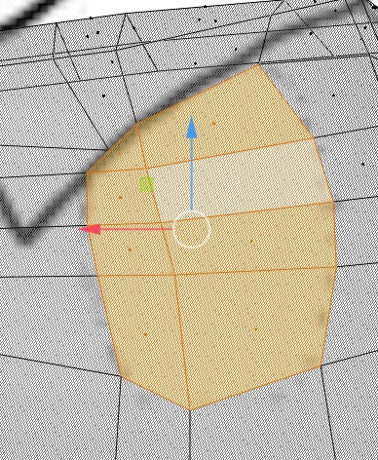

1. Click on the Extrude tool and extrude these faces.
2. Move and scale as needed and form an arm as shown below:

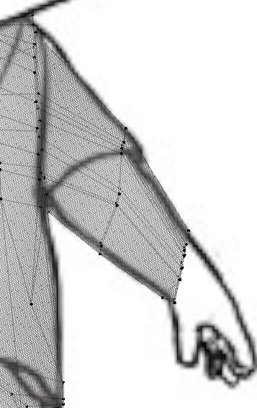

1. Extrude and move as needed.
2. Straighten up the sleeve as much as possible, as shown below:

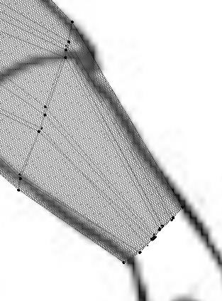

1. Extrude and move the end of the arm and form the hand as shown below:

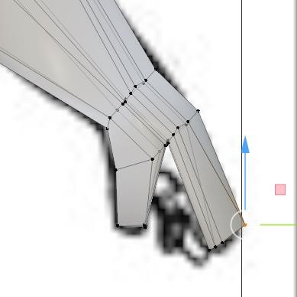

1. Go down to the feet.
2. Select all the bottom faces and extrude to form a basic foot.
3. Extrude and move as needed, for creating a foot such as this:

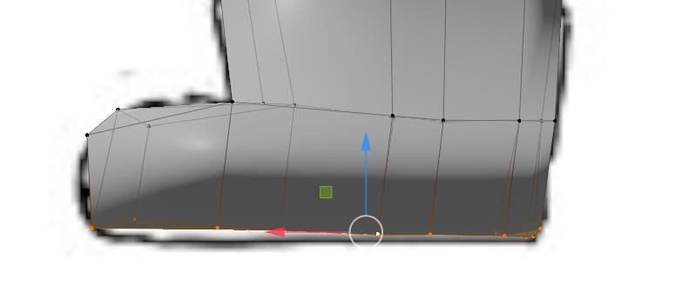

1. Switch to the side view.

|  |
| --- |
| **TASK 2.2:**  Take a screenshot of the side view and paste it below: |
|  |

# ACTIVITY 3

## Designing the Head

The head is designed separately and then it is attached to the body. Its size should be analogous to the body size to avoid any peculiar outcomes.

Follow the steps below:

1. Switch to Object Mode.
2. Add a new Cube.
3. Scale the cube approximately up to the head size of the background.
4. Turn to Edit Mode.
5. Right – Click and press S or select the Subdivide option.
6. Set the Number of cuts to 1 and the smoothness to 0.4 to 0.5, and create an asset such as below:

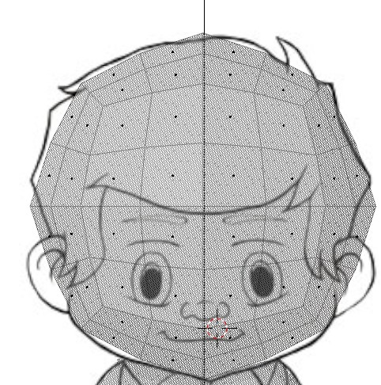

1. Click on the Faces select option and select the left side of the face.
2. Press Delete and then Face.
3. Click on the Vertex select option and move the vertices to match the shape of the head.
4. Switch to Object Mode.
5. Click on the Modifiers tab.
6. Click Add Modifier.
7. Select the Mirror Modifier.
8. Click Add Modifier.
9. Select the Subdivision Surface modifier.
10. Click Apply to both modifiers.
11. Select both meshes (Cube and Cube001) and press Ctrl-J.
12. Press Ctrl + S and save your progress.

|  |
| --- |
| **TASK 3.1:**  Take a screenshot of the front view and paste it below: |
|  |

1. Press B and select only the head.
2. Move the head up.
3. Select the faces as shown below:

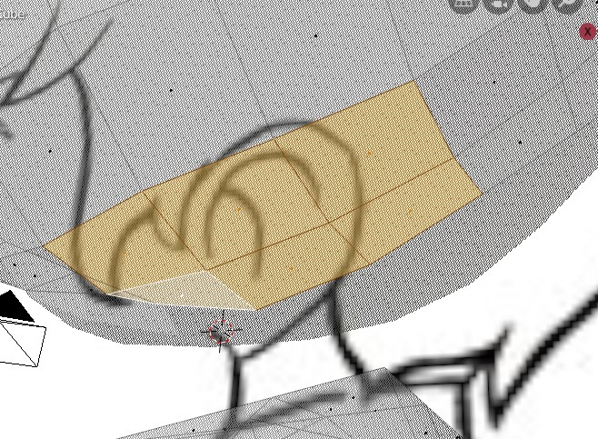

1. Press Delete and then Faces.
2. Select the Faces right across on the head on the body and press Delete.
3. Then select Faces.
4. Select the Edge Select tool.
5. Select the edges on the opposite sides and right – click.
6. Select Edge Loop.
7. Repeat and create a neck.
8. Move the individual vertices to match the shape.

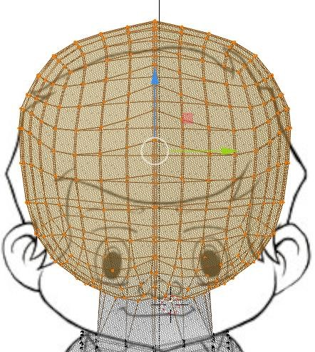

1. Select all the head faces and click on the Move tool.
2. Move downwards creating a very small neck (our image hardly has one).

Once you complete the previous steps:

|  |
| --- |
| **TASK 3.2:**  Take a screenshot of the front view and paste it below: |
|  |

1. Rename the cube to Character or Kid and save the project pressing Ctrl+S.
2. Switch to Object Mode.
3. Move the character to the side and inspect it all around.
4. Fix any problems.
5. Scale the character to match the actual size of a kid.
6. Try to create cuts close to the pivot points, such as the elbow, the knees, the neck, the belly.

# ACTIVITY 4

## EXPORTING AND IMPORTING TO UNITY

The last step is the exportation of the asset and the importation to the Game Engine. Follow the steps below:

1. Select the Character mesh under the Object mode.
2. Click File → Export FBX.
3. Click on the Selected Objects option.
4. Rename the asset to Kid.
5. Set an exporting path.
6. Press Export FBX.

|  |
| --- |
| **TASK 4.1:**  Locate the Kid.fbx file and add it to the submission folder. |
| In the LMS, add the file to the assignment Lab #13 submission folder. You can submit multiple files at a time. |

1. Press Export FBX.
2. Double – Click on the Unity shortcut.
3. Create a new 3D Unity project.
4. Name the new project 3DCharacterTest.
5. Under the Project tab, in the Assets folder, right click and Create → Folder.
6. Name the folder Character.
7. Right – click on the Character folder → Import New Asset.
8. Navigate to the file system and select the Kid.fbx file.
9. Click Import.
10. Click on the Kid asset and drag and drop it in the Hierarchy.
11. Move the camera on the character in the Hierarchy attaching it to the character object.
12. Rename the Kid to GameCharacter.
13. Move the Kids asset of the Camera to face the character:
    1. In Third Person.
    2. In First Person.

|  |
| --- |
| **TASK 4.2:**  Take a screenshot of your desktop with the Third Person View and paste it below: |
|  |

Once you added the third person, do the same with the first-person view:

|  |
| --- |
| **TASK 4.3:**  Take a screenshot of your desktop with the First Person View and paste it below: |
|  |

FINAL STEP: Save this document as a PDF. Upload the PDF to the Lab #13 submission folder.